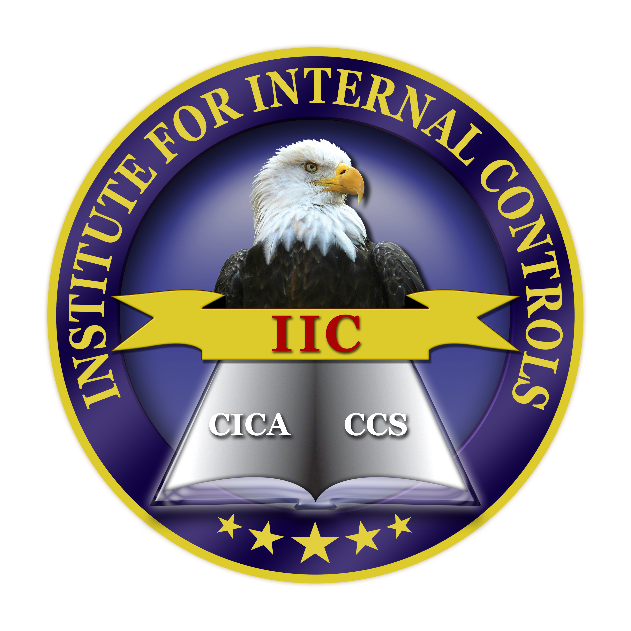 | Institute for Internal Controls  PRESS RELEASE  For Immediate Release | 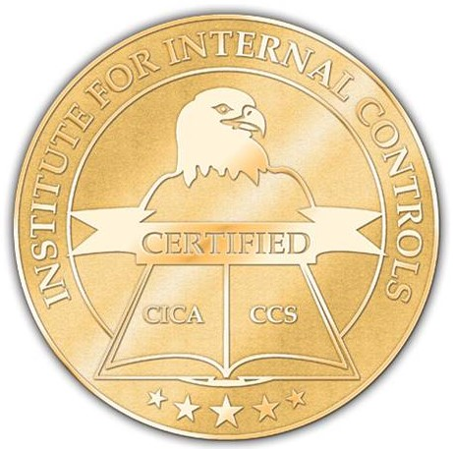

23 AUDITORS OF METROPOLITIAN BANK (Philippines) GRANTED CICA CERTIFICATION

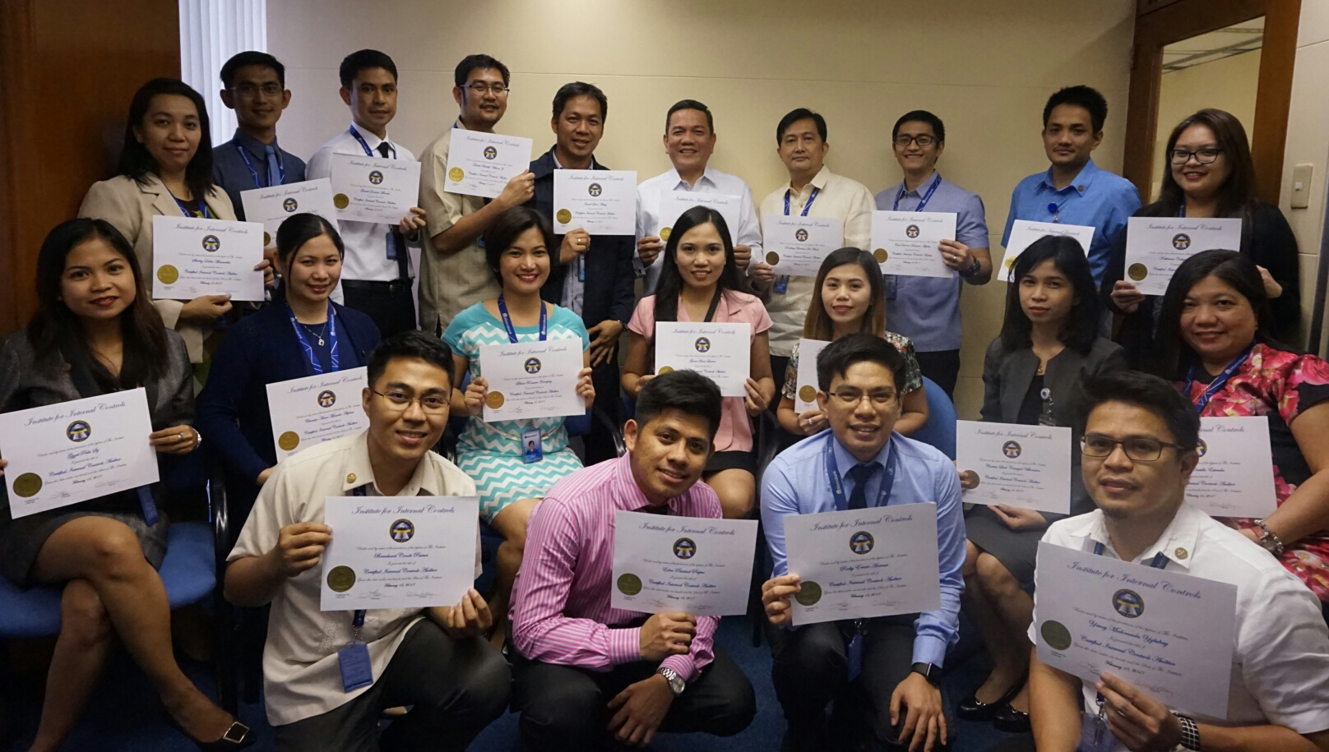

July 7, 2017 - Sicklerville, New Jersey U.S.A

Earlier this year, the Institute for Internal Controls (IIC/TheIIC) granted the Certified Internal Control Auditor (CICA) certification to 23 employees under the Internal Audit Group (IAG) of Metrobank including its Chief Audit Executive, Mr. Leo R. Fragante. CICA is a certification program for auditing professionals who are specialists in internal controls such as prevention and detection of fraud and other illegal acts, compliance to governing laws and regulations, and improvement of efficiency and effectiveness of operations and performance.

Metrobank IAG’s mission is to provide independent, objective assurance and consulting services designed to add value and improve the Bank’s operations. IAG promotes the highest level of professional competence and technical proficiency among its auditors. Other professional certifications of Metrobank IAG auditors include Certified Internal Auditor (CIA), Certified Information Systems Auditor (CISA), Certified Money Laundering Specialist (CAMS), Certified Fraud Examiner (CFE), Certification in Risk Management Assurance (CRMA), Certified Treasury Professional, and other similar certifications.

Based on the results of the last three external quality assessment review of internal audit activities, Metrobank IAG generally conforms to the International Standards for the Professional Practice of Internal Auditing, the Definition of Internal Auditing, and the Code of Ethics.

Metrobank is a leading financial conglomerate in the Philippines with diversified business portfolio including: investment banking, thrift banking, leasing and financing, bancassurance, and credit cards. It offers full range banking services to large local and multinational corporations, middle market and Small-medium enterprises, high net-worth individuals, and retail segment. Metrobank has a solid track record spanning over 50 years and is a multi-awarded bank, which received recognitions such as the Strongest Bank in the Philippines and ranked ninth overall in Asia in The Asian Banker 500 (AB 500). A recognized leader in the country's banking industry, Metrobank has become regarded as the trusted banking partner, staying true to its brand promise of "You're in Good Hands."
For more information about the Institute for Internal Controls visit TheIIC website at www.theiic.org or email TheIIC at info@theiic.org or call at 856.982.2410 Institute for Internal Controls, 109 Mullen Drive, Sicklerville, NJ 08081 U.S.A

